Invited Session Summary
Title of Session
Safe Planning and Control for Autonomous Driving Using Artificial Intelligence Technology
Name, Salutation, Affiliation and Email of Organizers
1. Assistant Prof. Mingyu Cai
University of California, USA
mingyu.cai@ucr.edu
2. AI Scientist. Shu Liu
Bosch Center for Artificial Intelligence (BCAI), China
shu.liu2@cn.bosch.com
3. Research Fellow. Jinhao Liang
National University of Singapore, Singapore
jh.liang@nus.edu.sg
4. Research Fellow. Yanbo Lu
Tsinghua University, China
luyb@mail.tsinghua.edu.cn
5. Assistant Prof. Faan Wang
Kunming University of Science and Technology, China
wfa@kust.edu.cn
6. Research Assistant. Zhenwu Fang
National University of Singapore, Singapore
zhenwu.fang@u.nus.edu
Biosketches and Photographs of Organizers (not more than 300 words per person)

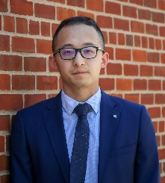
Dr. Mingyu Cai is currently an assistant professor in the School of Mechanical Engineering at the University of California, Riverside. Before this, he was a Postdoctoral Associate at Lehigh University and also a Research Scientist at Honda Research Institute. He received the Best Post Award at the 58th Midwest Workshop on Control and Game Theory, the 2019 University of Iowa Innovation Award, the 2019 Outstanding Graduation Award at the University of Florida, and the 2021 Best Dissertation Award for the Doctor of Philosophy. He served as the Session Chair at the 2021 IEEE/RSJ International Conference on Intelligent Robots and Systems (IROS) and as session co-chair for the 2022 IEEE International Conference on Robotics and Automation (ICRA), the 2022 American Control Conference (ACC), and the 2023 IEEE/RSJ International Conference on Intelligent Robots and Systems (IROS). His research interests include Robotics, Machine learning, Formal method, control, Reinforcement learning, Autonomous driving, and Safety-critical systems. Dr. Cai has published more than 20 papers in journals and proceedings of international conferences, and holds more than 10 patents in the field of autonomous driving technology.

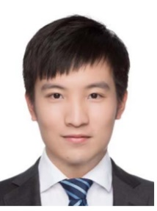
Shu Liu received the BSc degree from the Technical University of Munich, and the MSc and PhD degrees from ETH Zurich. His research interest includes machine learning, computer vision, and autonomous driving. He worked as a research assistant with the Computer Vision and Geometry Group of ETH Zurich in cooperation with MIT. He is currently an Al scientist with Bosch Center for Artificial Intelligence.

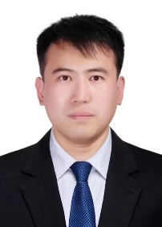
Dr. Jinhao Liang is currently a Research Fellow with Department of Civil and Environmental Engineering, National University of Singapore, Singapore. His research interests have focused on the vehicle dynamics and control, connected and autonomous vehicles, electric vehicles, vehicle-road cooperative control, etc. Moreover, Dr. Jinhao liang has published more than 50 papers in Journals and proceedings of international conferences. 10+ patents on Vehicle System dynamics and control. He won the Leading Prize for Autonomous Emergency Braking (AEB) assistance system at the 1st World Intelligent Driving Challenge. He serves as a member of the international program committee for the 2024 International Conference on Automation and Intelligent Technology. Moreover, he is an invited speaker at the 2023 6th International Conference on Mechanical Engineering and Applied Composite Materials.

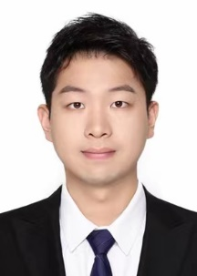
Dr. Yanbo Lu is currently a postdoctoral researcher at Intelligent and Connected Vehicles Lab, School of Vehicle and Mobility, Tsinghua University. His research interests include vehicle dynamics and control, fault-tolerant control and vehicle-cloud collaborative control. Moreover, Dr. Yanbo Lu has published more than 20 papers in Journals and proceedings of international conferences and 10 patents on Vehicle System dynamics and control. He has been honored the Shuimu Tsinghua Scholarship.

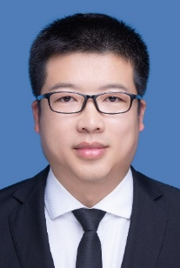
Faan Wang, Assistant Professor, Kunming University of Science and Technology, and now works in Kunming University of Science and Technology. His research interests are key technologies of intelligent transport equipment, including intelligent environment perception, multi-sensor information fusion, laser and visual SLAM, autonomous decision making and motion control system. The main social part-time jobs are: Member of the Chinese Society of Agricultural Engineering, member of the Chinese Society of Agricultural Machinery, member of the Chinese Society of Automotive Engineering, member of the Professional Committee of Agricultural Mechanization and Electrification, member of the Youth Committee of the Chinese Society of Agricultural Machinery, member of the Agricultural Machinery Maintenance Branch of the Chinese Society of Agricultural Machinery, member of the Yunnan Society of Agricultural Engineering, Deputy Secretary-General of the Yunnan Society of Agricultural Machinery.
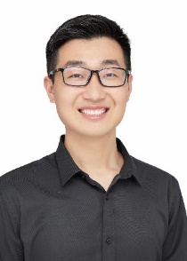
Dr. Zhenwu Fang is currently a joint PhD student with Department of Civil and Environmental Engineering, National University of Singapore, Singapore. He received the B.S. degree and the M.S. degree from Southeast University in 2017 and 2020, respectively. His research interests have focused on the vehicle dynamics and control, steering-by-wire control, human-machine shared control, etc. Moreover, Zhenwu Fang has published more than 10 papers in Journals and proceedings of international conferences and 20+ patents on steering-by-wire control and ADAS. He won the National Silver Award in the International College Student Innovation and Entrepreneurship Competition (2023). He served as a reviewer for IEEE Trans TE, IV, ITS and other journals. Additionally, He was responsible for the development of the commercial vehicle electro-hydraulic coupling steering system project, funded by Xiamen Jinlong United Automotive Industry Co., Ltd. He developed the digital twin autonomous driving HIL platform for Shenzhen Research Institute and COMAC Information Technology Co., Ltd.
Details of Session (background, purpose, significance and scope)
Autonomous driving represents a revolutionary shift, promising safer roads, and enhanced mobility in transportation. Consider, for instance, an autonomous vehicle navigating through urban traffic while avoiding other agents such as human-driven vehicles, and pedestrians. These scenarios pose critical safety challenges due to the unpredictability of these agents' intentions and behaviors, necessitating the estimation and integration of their a-priori unknown trajectories into the planning algorithm. Conventional approaches involve using historical trajectories to train a deep network, which is then incorporated into the path-planning process. Advancements in deep learning networks, statistical methods for quantifying uncertain prediction results, and engineering applications for the safe path-planning and control of autonomous driving are equally welcomed in this Special Session.
The invited session invites original papers of innovative ideas and concepts, new discoveries and improvements, and novel applications relevant to the following selected topics of “Safe Planning and Control for Autonomous Driving Using Artificial Intelligence Technology”.
    - Deep learning for trajectory prediction
    - Quantified representation for uncertain prediction results
    - Recognition and classification of human driver behaviors
    - Safe and robust control of autonomous driving
    - Cooperative control between autonomous vehicles and human-driven vehicles
    - Machine learning methods for autonomous path-planning
    - Modeling and advanced simulation of autonomous driving
    - Engineering examples and applications

